CT70A3100 Service Design

Tutorial Assignment - W4 Tutorial 4

Group 6
Hyechan Shin
Robert Gabrielsson
Juho Mänttäri
Amirhossein Mirsoleimani
Justyna Neuvonen

Introduction
In this tutorial, we created an actor map of LUT Primo and analyzed its value in interaction.

Actor Map
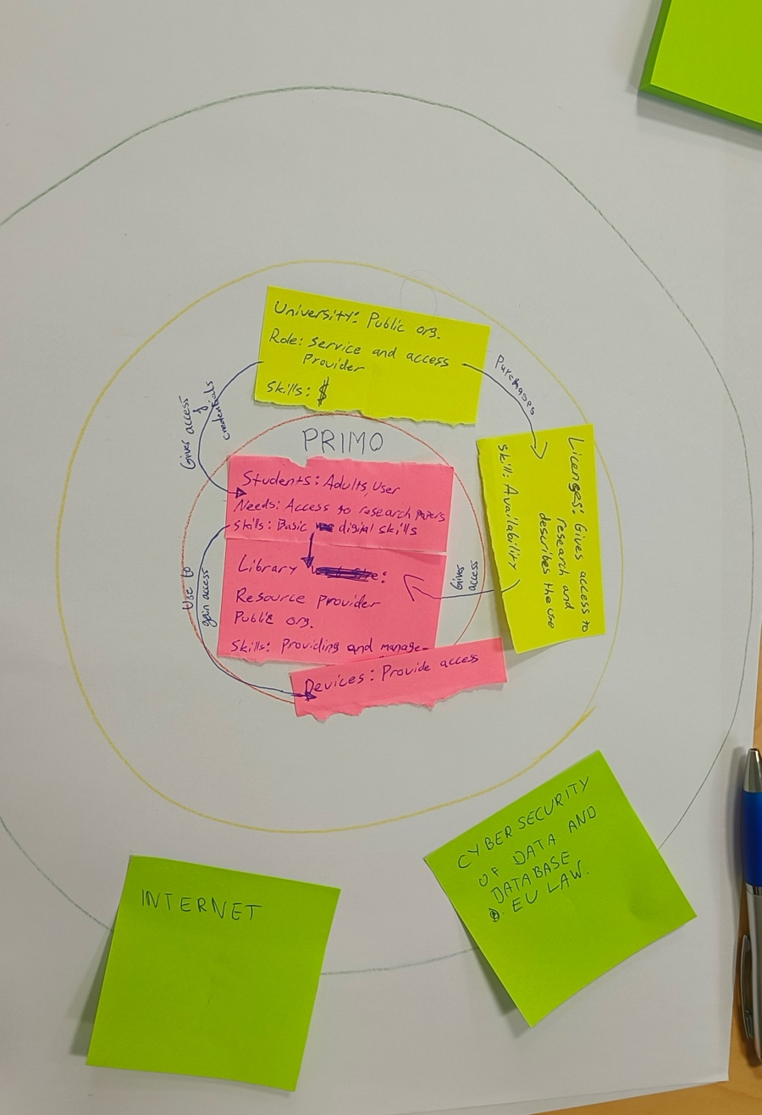
Primo is an online library where a user can borrow and read a digital copy of a book on their device. Our main users were students of university, adults, with basic digital skills. They would like to access the research papers, journals and books in easy way from their devices. To gain access they need to have credentials to log in to Primo. The library is main resource provider. They are providing and managing the database. They can also extend licesess or add needed publication on request. University is the provider of the access to this service. It is done by paying licences and access fees. University also buys licences and establishes what are the rules of using Primo (like time for access, time for digital loans etc). University through licences provides availability. The last circle is the one representing actors on which we are not able to influence easily. This would be the internet providers, EU laws, cybersecurity standards, data and databases.

Value in Interaction
The value for the student is in the access to the library. Easy, convenient and free possibility to make the research or learn. University is also having a value in rich database of publications with the library because it is showcasing how pro education and research is the University. Expanding the database for new licences opens the science for new interdisciplinary research.

Reflection - Main Takeaways
Main outcome of this tutorial was hidden connections to different entities, seemingly not connected to each other. We learned that even borrowing an ebook seems to be easy, but it can have various actors working together, even though the user doesn’t see them.

AI Clarification
No AI was used in this assignment.

